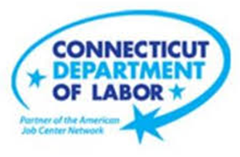

**NEW WEEKLY JOB POSTINGS FROM   
HELP WANTED ONLINE  
Office of Research**

**Week Ending April 9th, 2022: New Ads Continue 7th Consecutive Week Above 8,200**WETHERSFIELD, April 14th, 2022 – During the week ending April 9th, 2022, there were 8,498 new postings, down 648 new ads or -7% over the week. The most recent week of new ads is down slightly over the week, but marks the 7th consecutive week above 8,200 new ads. Most industries had over the week change of under 100 new ads, the three exceptions being Finance & Insurance (+409 new ads), Accommodation & Food Services (-158 new ads), and Health Care & Social Assistance (-429 new ads). The graph below illustrates how the monthly average of weekly new ads slumped from December to January and has been stronger in subsequent months. The total count of weekly job ads for the week ending April 9nd is double corresponding levels from a year ago (4,189 new ads on 4/10/21).

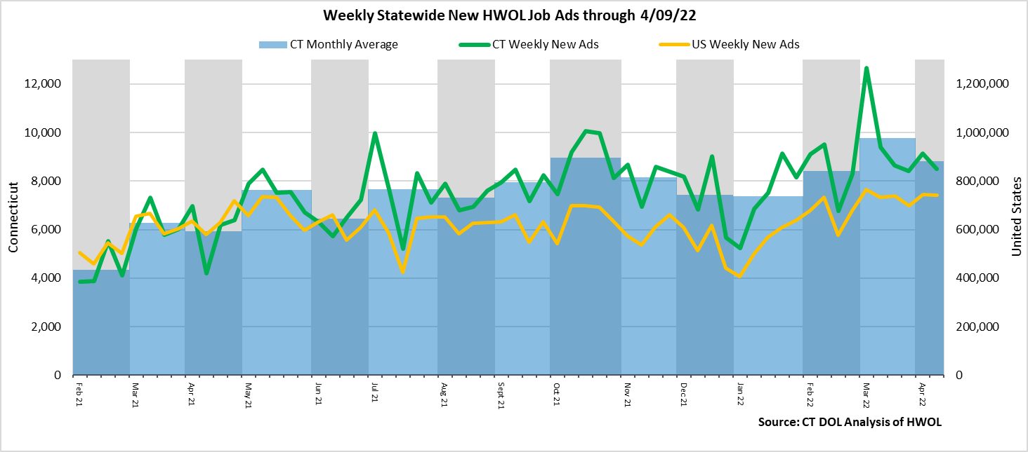  
**Industries** with the most new postings include Health Care & Social Assistance, Finance & Insurance, and Retail Trade.

**Occupations** with the most new postings include Registered Nurses, Retail Salespersons, Supervisors of Retail Sales Workers.

**Employers** with the most new postings include Capital One, Yale-New Haven Health System, and Tutored By Teachers.

**The three industries with the most new job postings where:**

* **Health Care & Social Assistance** (1,369 new postings, -24% over the week)
* **Finance & Insurance** (1,201 new postings, +52% over the week)
* **Retail Trade** (828 new postings, +6% over the week)

   
 During the week ending April 9th, the total ad decline of 648 new ads is the net result of change within 13 decreasing and 8 increasing industries. The 13 decreasing industries fell by a combined 1,230 new ads, with a third of that occurring in Health Care & Social Assistance (-429 new ads or -24%). The 8 increasing industries grew by a combined 582 new ads, with most of that occurring in Finance & Insurance (+409 new ads). The largest employers within the two largest decreasing and increasing industries were Yale-New Haven Health System (-64 new ads) and Capital One (+421 new ads). In Healthcare & Social Assistance, the occupation with the most ads was Registered Nurses (+222 new ads) and in Finance & Insurance, it was Bank Tellers (+24 new ads).   
  
 For more information on total job ads by industry for Connecticut and its labor market areas, see the monthly report available here: <https://www1.ctdol.state.ct.us/lmi/hwol.asp>

**New Job Postings by Occupation** 

**The occupations with the most new postings were:**

* Registered Nurses (289 new postings, -28% over the week)
* Retail Salespersons (229 new postings, -27% over the week)
* Supervisors of Retail Sales Workers (193 new ads, -3% over the week)

**Employers with the Most New Job Postings**

Employers with the most new job postings during the week were mostly in Healthcare, Finance & Insurance, and Retail Trade. The 25 employers shown above account for 21 percent of all new ads. Among the top 25 employers, 17 had over the week ad increases and 8 had decreases. The largest increasing top 25 employer over the week was Capital One (+421 new ads) and the largest decreasing employer was Raytheon (-67 new ads). Over four weeks, 18 of 25 employers shown above had increases and 7 had decreases. The largest of each was Capital One (+340 new ads and Hartford Healthcare (-485 new ads)

**What is HWOL?**The **Conference Board Help Wanted Online**® Data Series (HWOL) measures the number of new, first-time Online job postings and jobs reposted from the previous month for over 16,000 Internet job boards, corporate boards and smaller job sites that serve niche markets and smaller geographic areas. To view more HWOL data, go to: <https://www1.ctdol.state.ct.us/lmi/hwol.asp>